Connect SQL Server from Local DB

1. Download On-premises Data Gateway

<https://www.microsoft.com/en-us/download/details.aspx?id=53127>

1. Configure with your Email id (ex: [admin@vodafonejenkins.**onmicrosoft.com**](mailto:admin@vodafonejenkins.onmicrosoft.com))
2. Follow this steps
3. In the gateway installer, keep the default installation path, accept the terms of use, and then select **Install**.

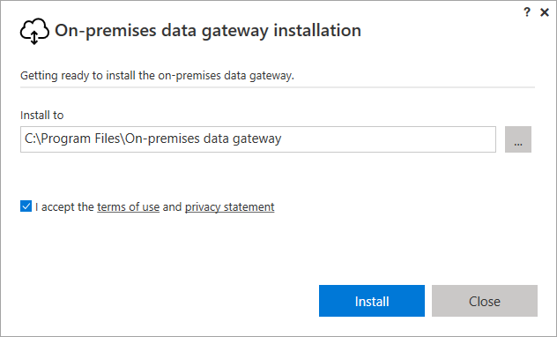

1. Enter the email address for your Office 365 organization account, and then select **Sign in**.

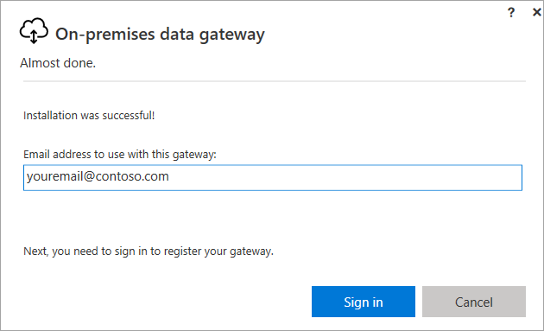

Select **Register a new gateway on this computer** > **Next**.

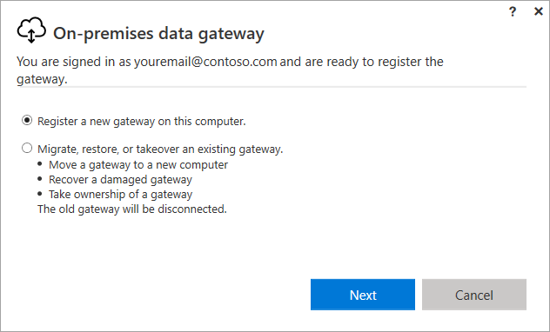

1. Enter a name for the gateway. The name must be unique across the tenant. Also enter a recovery key. You'll need this key if you ever want to recover or move your gateway. Select **Configure**.

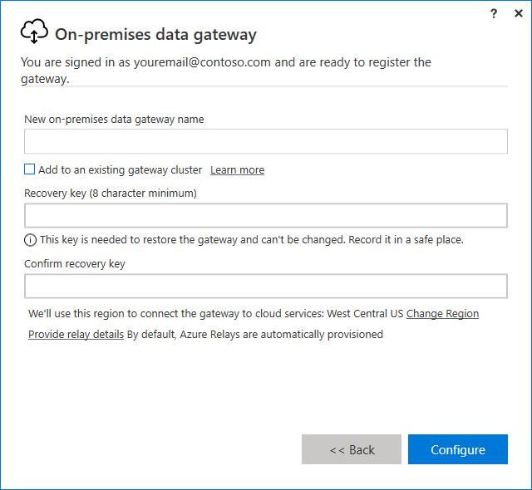

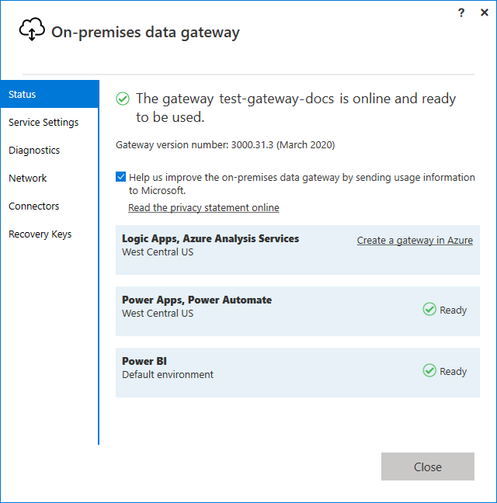

Now that you've installed a gateway,

1. Create an CanvasApp
2. Add Data source
3. Add SQL Connector

1. Configure your SQL Server connection

* Authentication Type – Windows Authentication/SQL Authentication/….
* SQL database name
* User Name
* Password
* Select Gateway

Click Connect to connect the data source using Gateway

1. Select Table

Then add the data to Gallery / data table control or curd operations

Test it

